Workflow & Prompts - Ramesh's Summer Market
A technical breakdown of the generative pipeline, video parameters, seed specifications, and exact generation prompts for the animated short story Ramesh's Summer Market.

Workflow Overview
The technical pipeline uses AI-driven video and voice models to create hand-drawn 2D animation, followed by professional post-production editing for final assembly, colour, and any audio.
Pipeline Component | Specification / Tool | Parameters
Video Model | Lightricks LTX-2.3 (image-to-video)  Released March 5, 2026 | Duration: 5.0s per shot  Resolution: 1280 x 720  Frame rate: 25 fps  Total runtime: about 40s
Audio Model | FL Chatterbox Multilingual TTS  Voiceover narration from the script | Voice generation seed: Not specified  Narration: 6 lines, see Voiceover & Audio Specifications
Editing & Assembly | DaVinci Resolve | Master timeline assembly in shot order  Closing message added to the clean centre area of Shot 8  Colour grade and music sync

Shot Breakdown & Generation Prompts
Shot 1
- Prompt: A cinematic wide establishing shot of a traditional outdoor street market in Delhi, India, early morning. Ramesh, a 45-year-old Indian fruit vendor with warm brown skin, short black hair, thick black moustache, cream cotton shirt and faded green apron, opens his small fruit cart. He carefully arranges bright mangoes, bananas, oranges and watermelons. Indian shopfronts, Hindi signage, parked scooters, an auto rickshaw in the background, overhead electrical wires. Gentle morning sunlight. He smiles while preparing his stall. Traditional hand-drawn 2D golden-age theatrical cartoon animation, expressive characters, bold black outlines, hand-painted background, traditional cel animation, rich colours, cinematic wide composition, 2D only.
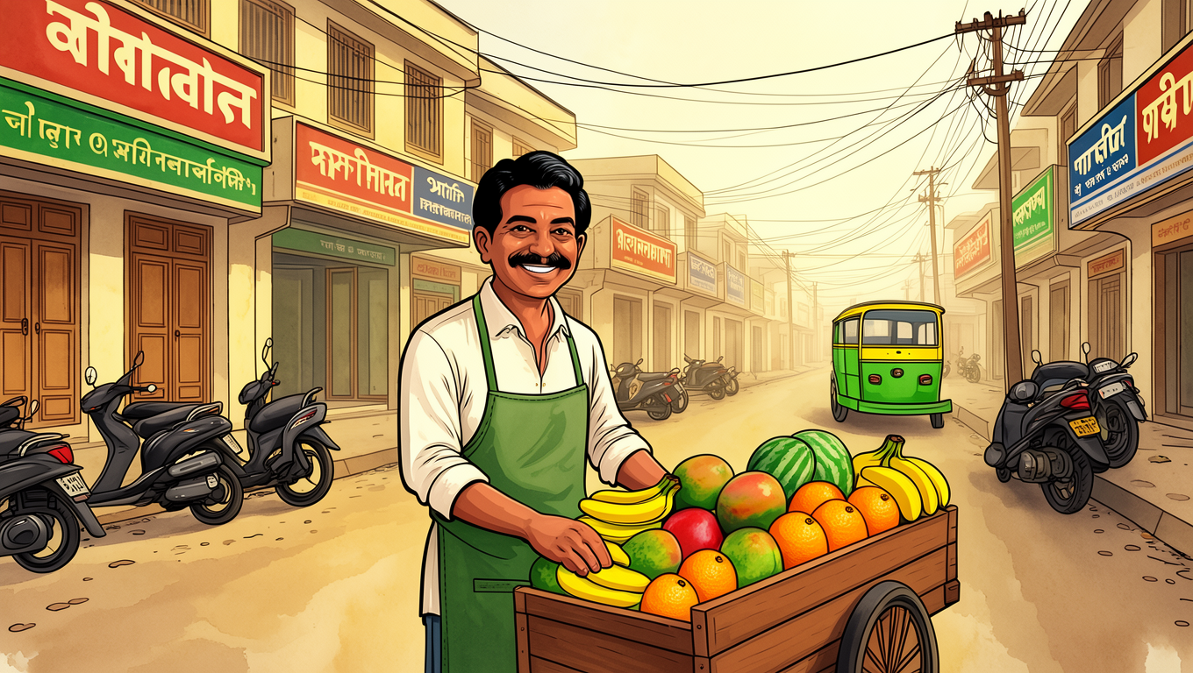
Shot 2
- Prompt: The same Delhi street market and exactly the same fruit stall from the previous shot, now during an extremely hot summer afternoon. The sun shines harshly overhead. Strong sunlight falls directly onto Ramesh and his unshaded fruit cart. Heat haze shimmers above the road. Ramesh, wearing the same cream shirt and faded green apron, wipes sweat from his forehead with his hand. The street looks dry and uncomfortable. Bright harsh yellow sunlight and warm orange tones. Traditional hand-drawn 2D cartoon animation, bold clean black outlines, expressive character animation, hand-painted Indian urban background, traditional cel animation, consistent character and environment design.
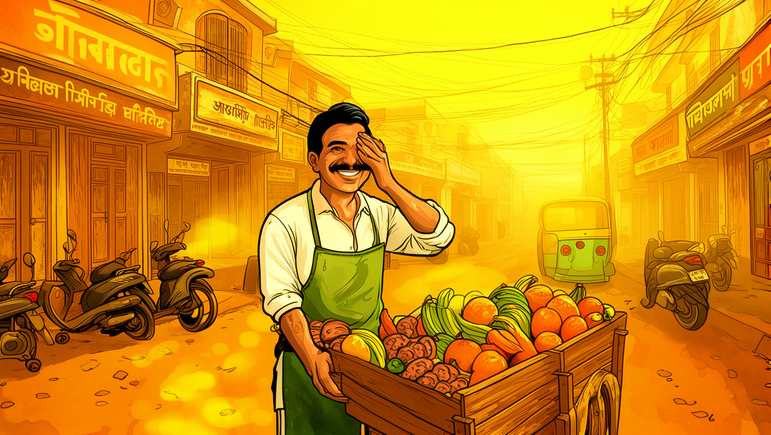
Shot 3
- Prompt: The same outdoor Delhi fruit market in the same extreme summer afternoon. Ramesh stands behind his familiar fruit cart, watching the nearly empty market. Two pedestrians walk quickly past without stopping, protecting themselves from the harsh sun. Empty space around the stall, quiet road, closed umbrellas and bright sunlight. Ramesh looks disappointed and worried. The same mangoes, bananas and oranges are visible. Traditional hand-drawn 2D golden-age cartoon animation, bold black outlines, hand-painted background, expressive facial acting, consistent character design, cinematic composition, 2D cel animation.
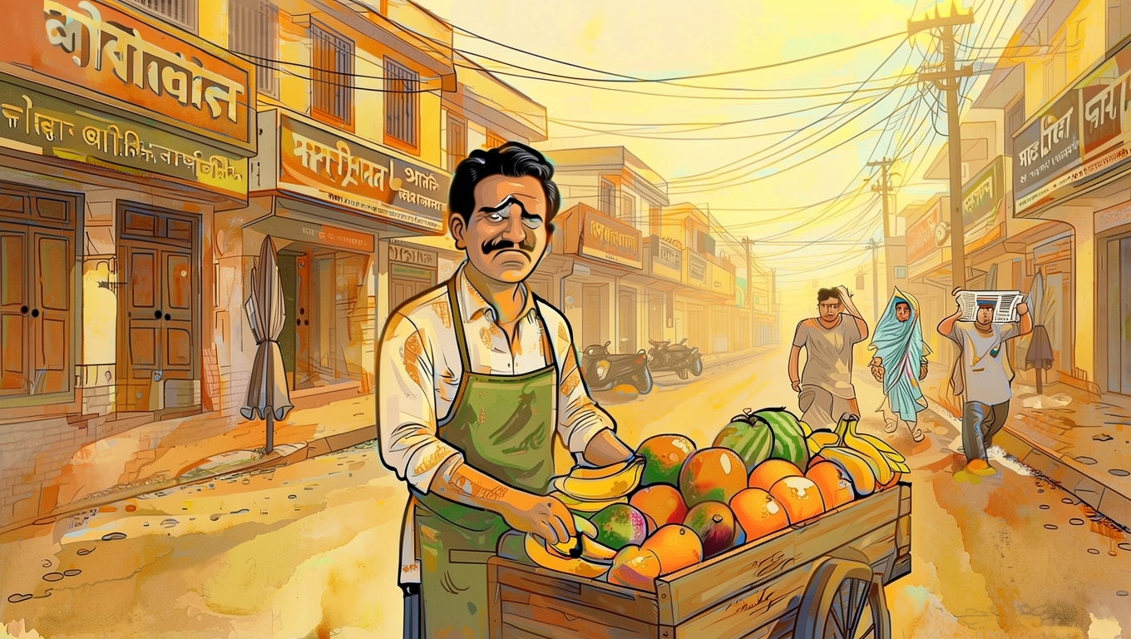
Shot 4
- Prompt: A medium close-up of Ramesh at the same Delhi fruit stall during the hot afternoon. A few mangoes and bananas show visible signs of heat damage and softening. Ramesh looks exhausted, sweat running down his face, his shoulders lowered. He looks at the fruit that he could not sell. Harsh sunlight falls directly across the stall. His expression is quietly emotional, realistic within a cartoon style. Traditional hand-drawn 2D theatrical cartoon animation, expressive face, bold black outlines, painted background, traditional cel animation, rich warm colours, consistent Ramesh character design.
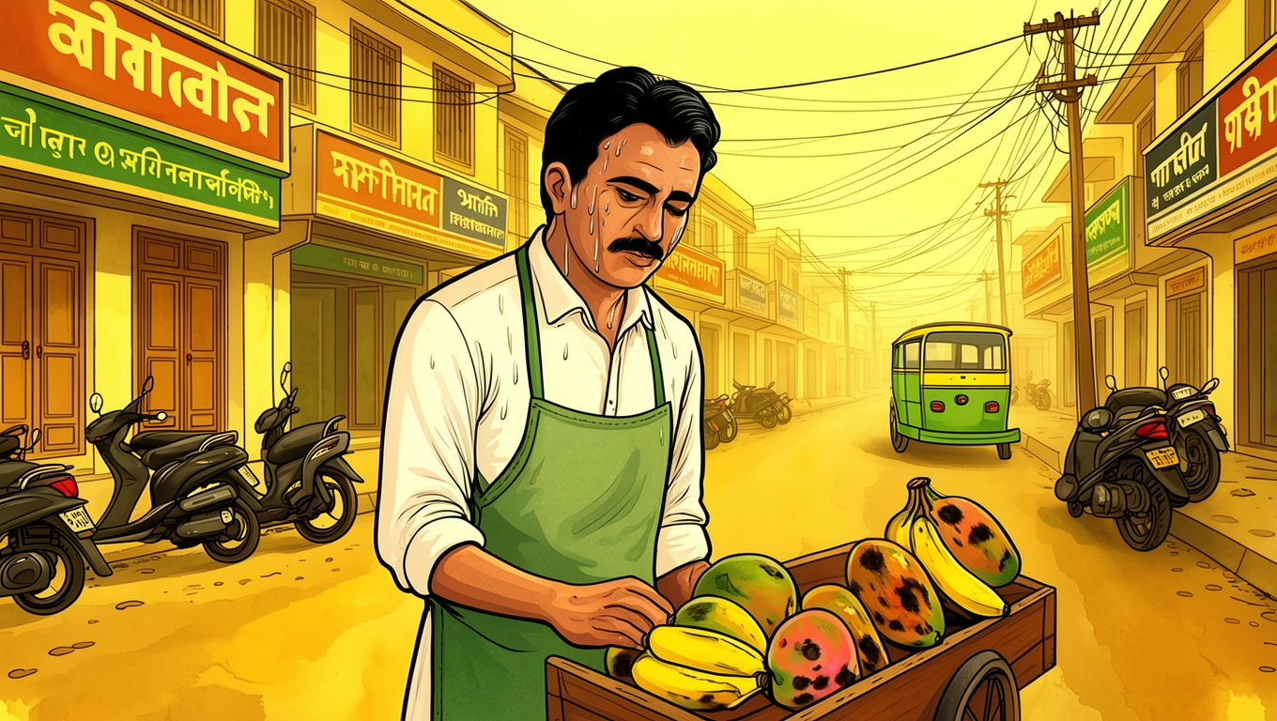
Shot 5
- Prompt: The same Delhi street market. A fictional Indian municipal official, approximately 40 years old, wearing a light khaki shirt and trousers with an ID badge, stands beside Ramesh's fruit stall. The official holds a clipboard and carefully observes the unshaded market. Ramesh gestures towards the direct sunlight and his exposed stall. The official looks concerned and studies the lack of shade and drinking water facilities. The same market buildings and fruit cart remain in the background. Traditional hand-drawn 2D cartoon animation, bold outlines, expressive characters, painted Delhi market environment, cinematic composition, consistent 2D cel animation.
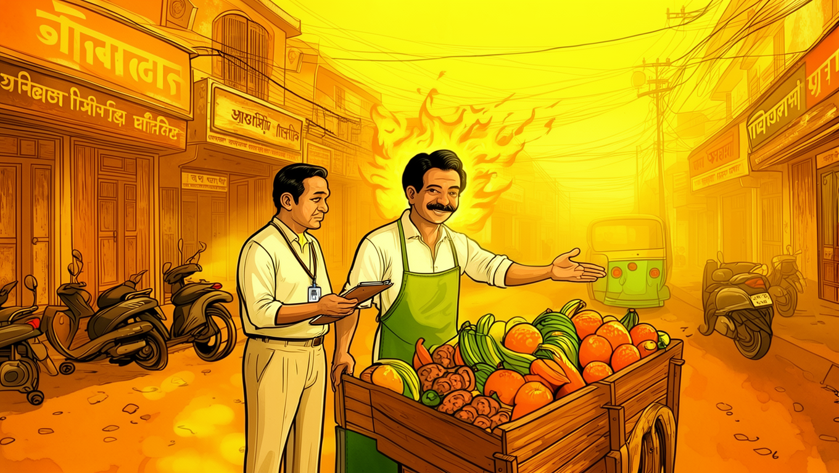
Shot 6
- Prompt: The same Delhi street market, now showing a practical climate adaptation improvement. A large durable shade canopy covers the fruit vending area, protecting Ramesh and neighbouring vendors from direct sunlight. A clean public drinking-water station is installed near the stalls, with a visible water tap and drinking water sign. Ramesh looks pleasantly surprised and relieved. The market layout, buildings and fruit cart remain consistent with previous shots. Traditional hand-drawn 2D golden-age cartoon animation, bold black outlines, expressive character design, hand-painted Indian market background, warm colours, traditional cel animation, 2D only.
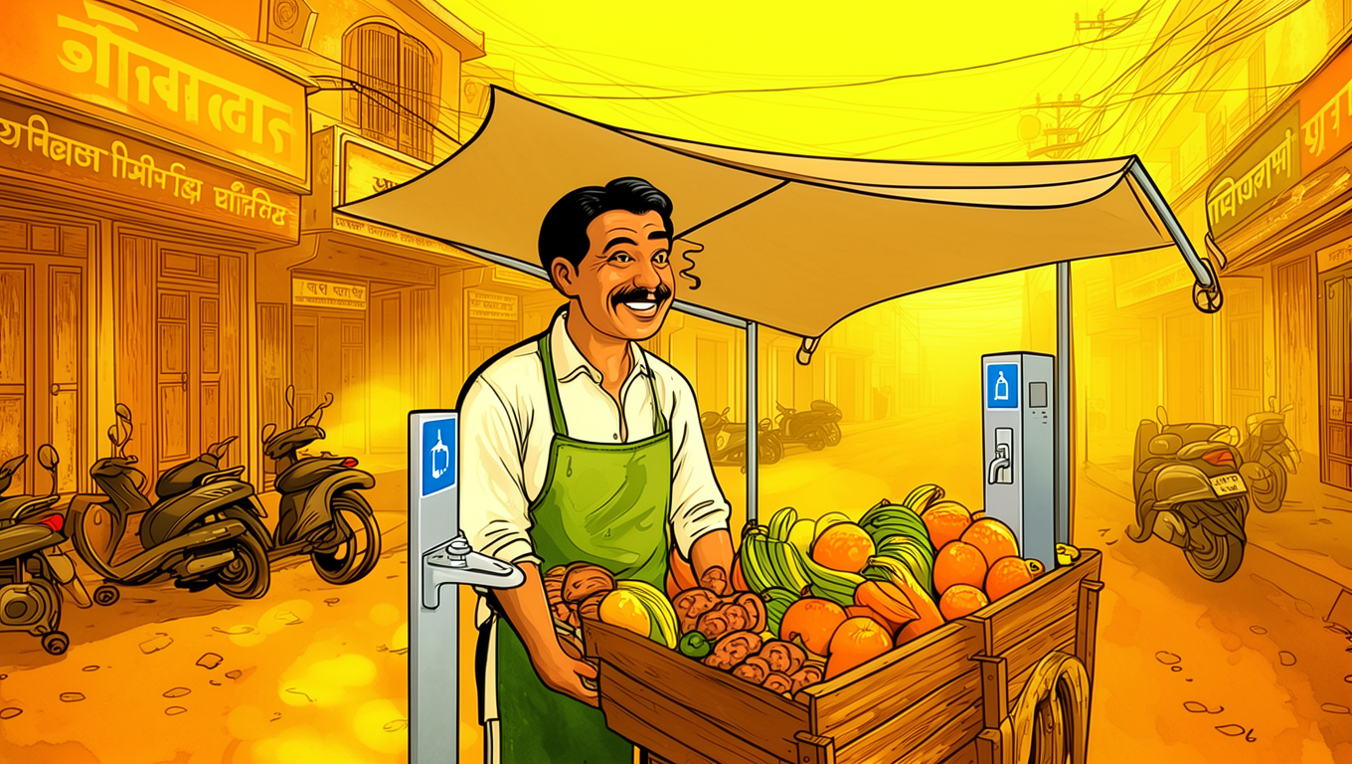
Shot 7
- Prompt: The same Delhi street market with the newly installed shade canopy and public drinking-water point. Ramesh, wearing his unchanged cream shirt and faded green apron, happily serves a customer at his fruit cart. A customer selects fresh mangoes. Another vendor drinks water nearby. The fruit stall is protected from direct sunlight. The market looks active and welcoming. The scene communicates dignity, protection and climate resilience rather than exaggerated happiness or a perfect solution. Traditional hand-drawn 2D theatrical cartoon animation, expressive characters, bold outlines, hand-painted background, consistent character proportions, traditional cel animation.
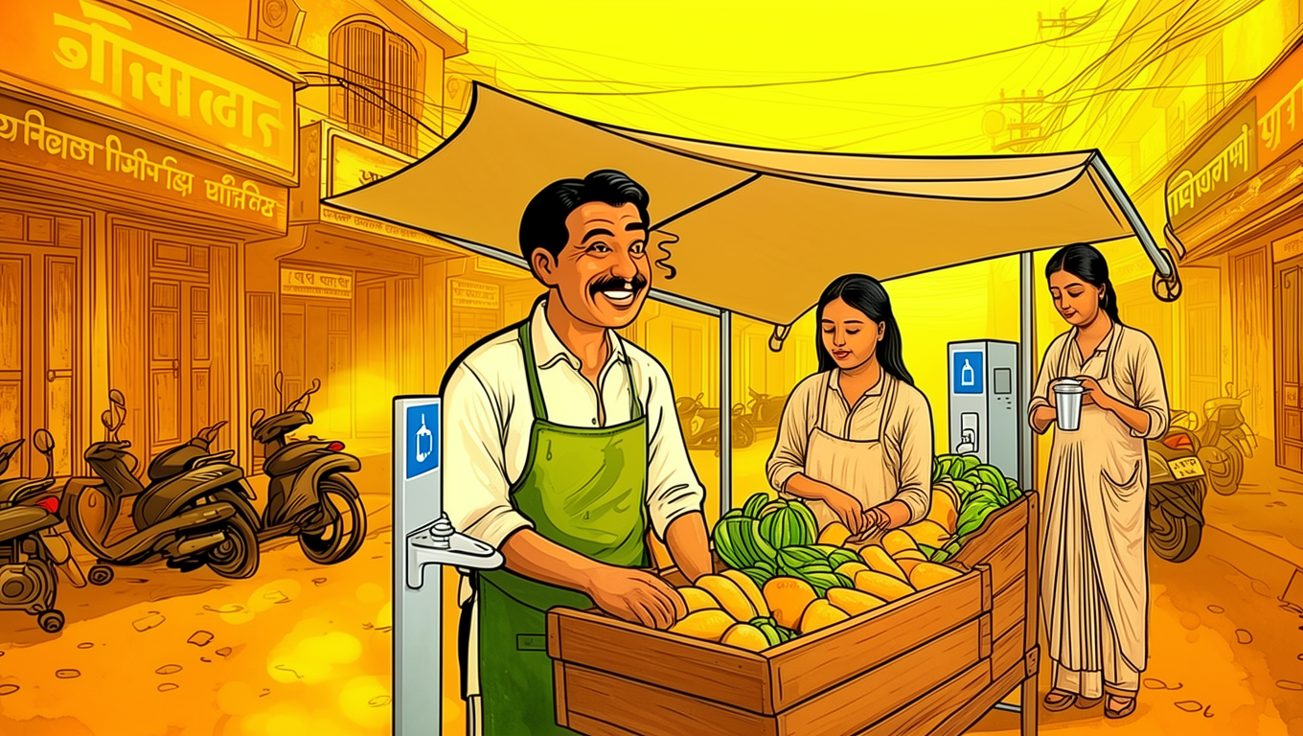
Shot 8
- Prompt: A cinematic wide final view of the same Delhi street market. The fruit stalls are protected by large shade canopies. Ramesh stands behind his familiar fruit cart, working peacefully. The drinking-water station is visible nearby. Warm late-afternoon sunlight creates a hopeful atmosphere. Leave a large clean uncluttered area in the centre of the composition for a closing message to be added during editing. Strong visual composition, memorable ending. Traditional hand-drawn 2D golden-age theatrical cartoon animation, bold black outlines, painted background, traditional cel animation, rich colours, consistent characters and environment.
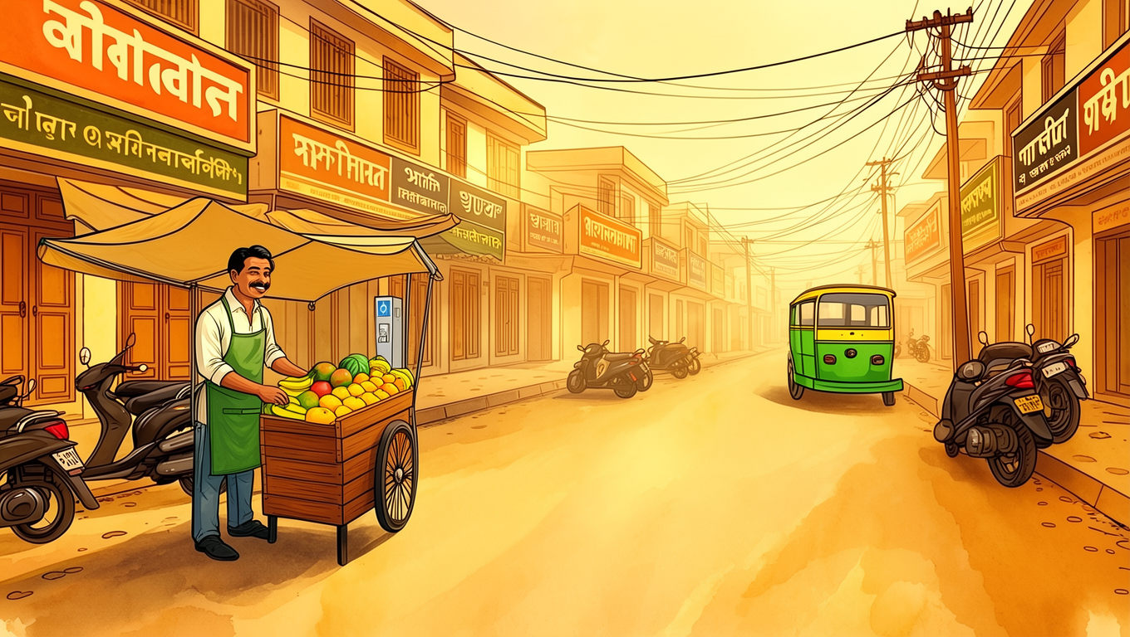

Voiceover & Audio Specifications
- Voice Generation Seed: Not specified
- Script / Audio Prompt: “Every morning, Ramesh opens his little fruit stall, hoping for another good day. But as the temperature rises, the streets grow quieter. Customers disappear. The fruit begins to spoil. And every passing hour costs him more than money. For vendors like Ramesh, extreme heat is not just uncomfortable. It threatens their livelihood. Shade and drinking water can make a difference. Because our cities must protect the people who keep them running.”

